**Types of Activities:**

1. **Questionnaires to be filled out baseline, week 4 and week 10 (Paused? TBC)**
2. **Quizzes (MCQ, 1 answer)**

*Eg. Nutrition*

There are three main layers of the food pyramid. The bottom layer is the most important one for your daily intake of food. It contains vegetables, fruits, grains and legumes. You should be having most of your daily food from this layer. These foods are all derived or grow on plants and contain important nutrients such as vitamins, minerals and antioxidants. They are also responsible for being the main contributor of carbohydrates and fibre to our diet.

The middle layer is comprised of dairy based products such as milk, yoghurt, cheese. These are essential to providing our bodies with calcium and protein and important vitamins and minerals.

They layer also contains lean meat, poultry, fish, eggs, nuts, seeds, legumes. These foods are our main source of protein and are also responsible for providing other nutrients to us including iodine, iron, zinc, B12 vitamins and healthy fats.

The top layer, which is the smallest layer, is the layer you should me eating the least off. This layer is made up of food which has unsaturated fats such as sugar, butter, margarine and oils; small amounts of these unsaturated fats are needed for healthy brain and hear function.

*Quiz*

*Which of these breakfast foods will provide you with the most energy?*

A Candy bar

B Whole grain cereal or oatmeal

C Potato chips

D Quiche

*Which type of food should you have more of each day?*

A Fruits and veggies

B Meats

C Grains

D Vitamins

1. **Video, followed by short answer questions (SAQ)**

*Eg. Smoking*

Video Start of with a Truth Video (Can get these on YouTube) (1 minute)

Short Answer Questions:

What do you think the message behind this video was?

Do you think that this video is effective? Why/why not?

1. **Small text, infographic (todo: interactive)**

*Eg. Nutrition*

Eating a balanced diet is vital for your health and wellbeing. The food we eat is responsible for providing us with the energy to do all the tasks of daily life. For optimum performance and growth a balance of protein, essential fats, vitamins and minerals are required. We need a wide variety of different foods to provide the right amounts of nutrients for good health. The different types of food and how much of it you should be aiming to eat is demonstrated on the pyramid below.

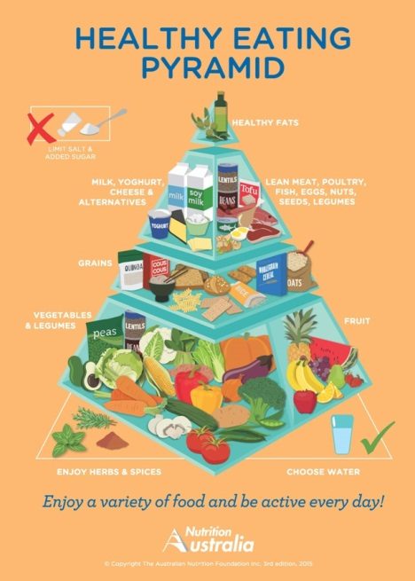

1. **Blank paint screen (API upgrade)**

*Eg. Self-Development/Dropping out*

What would you like to achieve this school term? Make board with pictures of what you would like to achieve and the people and things that inspire you and what you aspire to be. You can also put down things about yourself that you would like to improve on. If you would feel more comfortable using words or pictures that only you know what they mean, you can. After all, some goals are personal. (todo: sticker image size limitation)

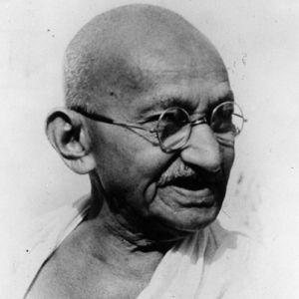

**Get 2 a’S This term**

**Start Basketball**

1. **Short Answer questions** *Eg Exercise*
2. How much exercise do you think you do a day?
3. Do you think that you are exercising enough? Why/whynot?
4. What are the benefits of exercising? List 5 examples
5. What changes can you make to your daily routine to incorporate more exercise into your life?
6. **~~Role models (picture and quote about healthy lifestyles perhaps Port Adelaide?)~~**

Quote about healthy lifestyles from celebrities………………………………………………………………………………………………………………………………………………………………………………………………………………………………………………………………………………………………….

Picture of celebrity

*(Please ask Tim where he imagines this to be, I think it is currently on the home page at the moment)*

1. **~~Finding information from page within the website~~**

*Eg. Nutrition*

*Find the definition of the below nutrients and why each is important for your health:*

a) Protein

b) Carbohydrate

c) Fat

d) Vitamin

e) Mineral

You can use the iSNAP page to do this.

1. **Cost Calculator**

<https://www.cancersa.org.au/quitline/cost-calculator>

What would the cost be of smoking 10 cigarettes a day for 10 years if a packet of 20 cigarettes costs $25?

What would the cost be of smoking 20 cigarettes a day for 20 years if a packet of 20 cigarettes costs $25?

What would the cost be of smoking 40 cigarettes a day for 20 years if a packet of 20 cigarettes costs $25?

1. **Matching games**

Match the diseases to the causes. You may have to do some research on other websites to find out the answers.

|  |  |
| --- | --- |
| DISEASE | CAUSE |
| 1 Kwashiorkor | A This condition is brought on by a lack of vitamin D |
| 2 Marasmus | B A disease that occurs if your body doesn’t get enough proteins |
| 3 Scurvy | C Occurs in young children who don’t get enough calories every day. |
| 4 Rickets | D Caused by the deficiency of vitamin B1 (thiamine) |
| 5 Beriberi | E Caused by a lack of vitamin C |

Answers: 1b, 2c, 3e, 4a, 5d

Developers: Setup a creative way to do the matching game-visually appealing.

Source: <http://www.english-online.at/health_medicine/nutrition/nutrition-how-the-body-uses-food.htm>

http://mentalfloss.com/article/50697/4-diseases-caused-lack-essential-vitamins-and-minerals

1. **Nutrition Activity: (TBC, at last or negotiate)**
2. Design the breakfast, lunch and dinner that you would like to have on any particular day: You can use any combination of the different food and categories below:

|  |  |  |
| --- | --- | --- |
| **Carbohydrates** | **Dairy** | **Fruit & vegetables** |
| Boiled rice | Skim milk | Apple |
| Grain bread | Reduced fat milk | Undressed leafy salad |
| White bread | Regular milk | Broccoli |
| Corn flakes | Low fat yoghurt | Carrot |
| Instant noodles | Cheddar cheese | Orange |
| Plain boiled pasta | Processed cheese | Peas |
| Instant porridge | Cream | Potato, boiled |
| Natural untoasted muesli | Light sour cream | Banana |
|  |  |  |
|  |  |  |
| **Meat, poultry and fish** | **Takeaway** | **Beverages** |
| Roast lamb (fat removed) | Fried rice | Milk |
| Sausage | Hot chips or fries | Flavoured milk |
| Tuna in brine | Meat pie | Water |
| Beef stir-fry | Sushi rolls | Regular soft drink |
| Crumbed frozen fish | Caesar salad (no meat) | Fruit or orange juice |
| Egg | Chicken doner kebab | Iced tea |
| Skinless chicken drumstick | Pizza 3 slices | Instant coffee |
| Marinated chicken wings | Fast food burger | Milo powder |

1c) Knowing that each of the Kj intake is listed next to each item how would you redo your meals for a day?

Developers: The participants choose the foods above, if possible we would like to make this as visually appealing as

possible, is it possible for a picture of the item they choose eg pizza = 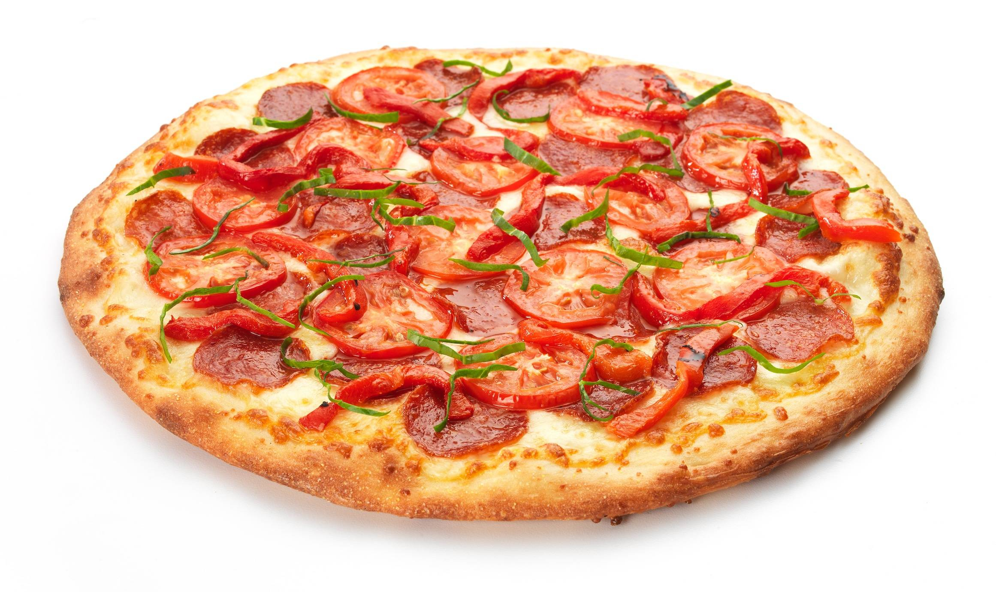 to come up when they choose the word? Ideally these meals would appear in a box like this in the same manner. We would like the kilojules of the items to come up after the end of the activity, after they have chosen all 3 meals.

We want to be able to get this info: Did you know that the standard Kilojule intake for youth aged between 12-15 years old is 10,900Kj for Males and 9,550 Kj for Females. The meal that you made has a total of……Kj. That is 8000Kj over what is recommended for your age!...Or that is 5000 Kj under what is recommended for your age….Or Congratulations your bang on target! That’s the right Kj intake recommended for your age.

Example: **Breakfast Lunch Dinner**

450 Kj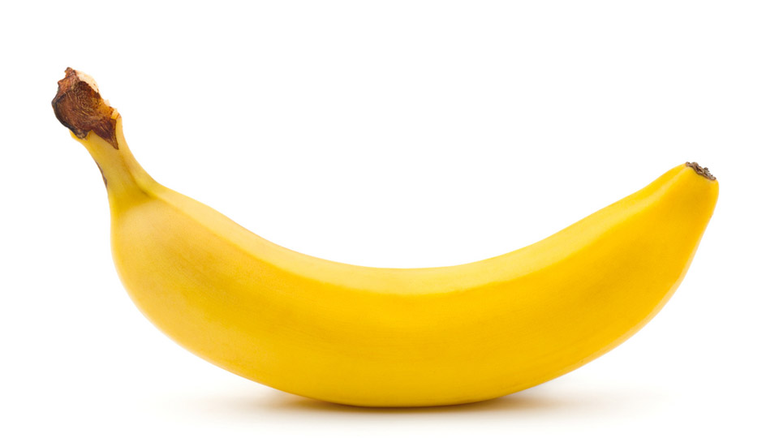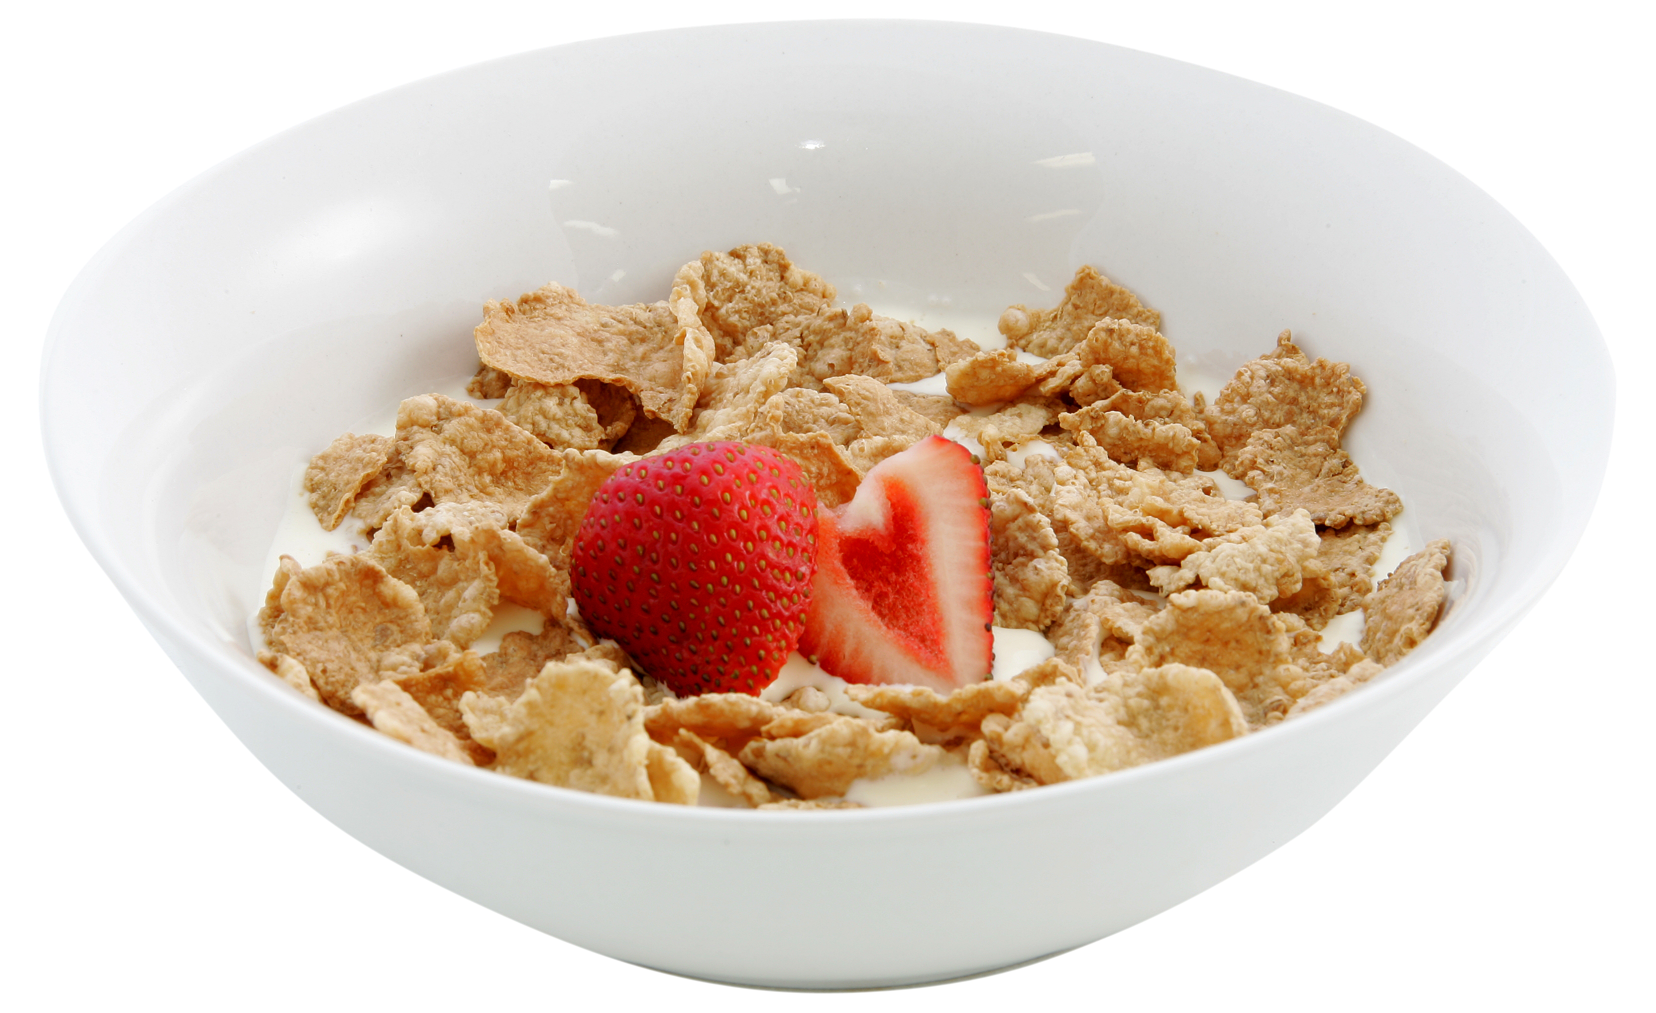

200Kj etc 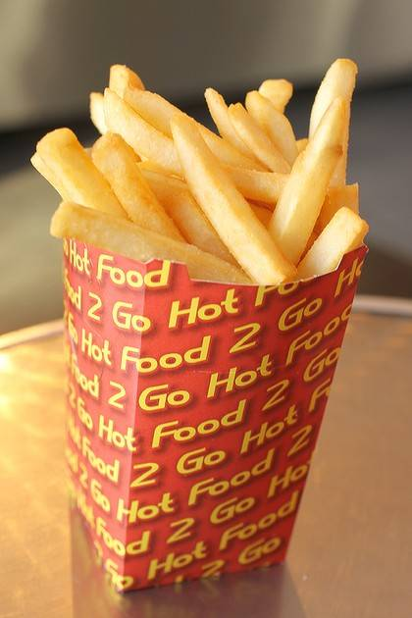 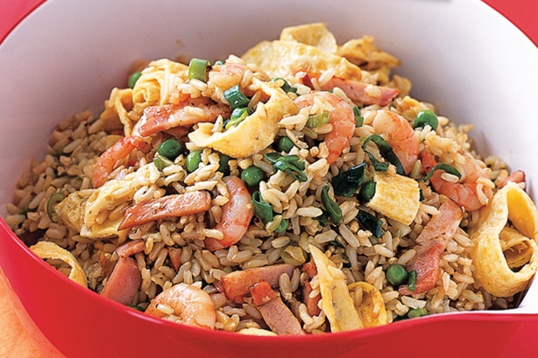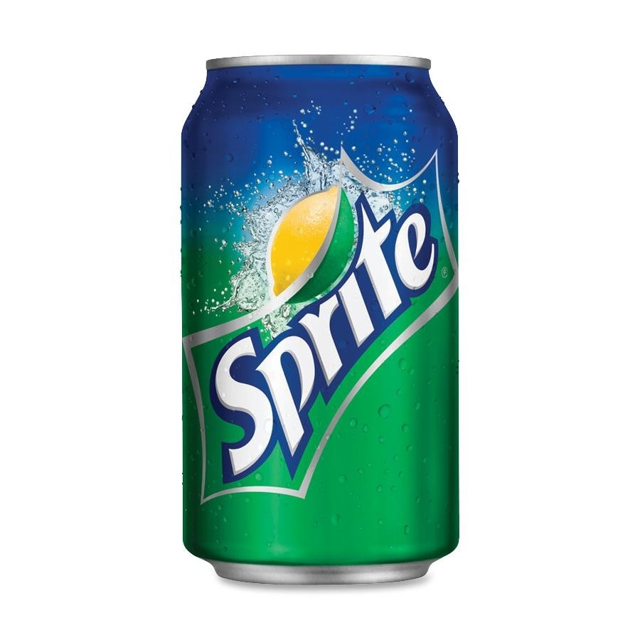

|  |  |  |
| --- | --- | --- |
| **Carbohydrates (Kj)** | **Dairy (Kj)** | **Fruit & vegetables (Kj)** |
| Boiled rice (930) | Skim milk (370) | Apple (330) |
| Grain bread (830) | Reduced fat milk (530) | Undressed leafy salad (65) |
| White bread (800) | Regular milk (730) | Broccoli (65) |
| Corn flakes (455) | Low fat yoghurt (650) | Carrot (110) |
| Instant noodles (1340) | Cheddar cheese (345) | Orange (385) |
| Plain boiled pasta (670) | Processed cheese (290) | Peas (220) |
| Instant porridge (595) | Cream (1750) | Potato, boiled (295) |
| Natural untoasted muesli (510) | Light sour cream (1160) | Banana (420) |
|  |  |  |
|  |  |  |
| **Meat, poultry and fish (Kj)** | **Takeaway (Kj)** | **Beverages (Kj)** |
| Roast lamb (fat removed) (350) | Fried rice | Milk |
| Sausage (850) | Hot chips or fries | Flavoured milk |
| Tuna in brine (1040) | Meat pie | Water |
| Beef stir-fry (965) | Sushi 3 long rolls | Regular soft drink |
| Crumbed frozen fish (875) | Caesar salad (no meat) | Fruit or orange juice |
| Egg (620) | Chicken doner kebab | Iced tea |
| Skinless chicken drumstick (350) | Pizza 3 slices | Instant coffee |
| Marinated chicken wings (1530) | Fast food burger | Milo powder |

Developers: The rest of the Kj will be added in later but you get an idea of the setup. It is a repeat of 1a but we are hoping they will choose better options this time.

Source: <http://www.myhealthyliving.com.au/health-research/my-calorie-chart#sthash.W9BhGDL3.dpuf>

1. **Caption and image: (SAQ)**

*Eg Physical Activity*

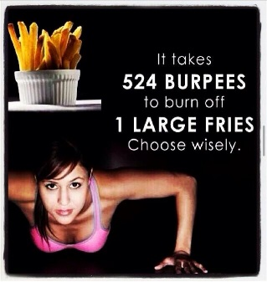What caption would you write for this image?

What do you think the main message about this image is?

1. **Infographic and questions after:**

Sex Education:

Designer Create infographic: *54 per cent of surveyed students reported receiving a sexually explicit text message and 26 per cent reported sending a sexually explicit photo of themselves.*

Questions:

1. Does this surprise you? Why/why not?
2. Do you think sexual education programs need to incorporate elements such as this into existing programs? Why/why not?
3. Do you see any risks associated with the increase in prevalence amongst youth with sexting? Why/why not?
4. **Standard Drink Tool (copy & paste)**

[**http://alcoholthinkagain.com.au/**](http://alcoholthinkagain.com.au/)

**auto-graded**

1. ~~List Pros vs Cons~~

Activity: A friend of yours is thinking about dropping out of school after year 10. They think that it will be easier for them to not go through the studying and hassle that often comes with completing year 11 and 12.

Do you think that your friend should drop out of school? Why/why not?

List the positives and negatives that can result to your friend as a result of his choice.

(Minimum of 5 each)

Negatives

**Positives**

1. **Classify the lists of foods into the 6 main food groups: (auto-graded)**

Potato chips

Beef

Iron

Zinc

Rice

Pasta

Fish

Milk

Tomatoes